Name.
Tutor.
Course.
Date.
The Crystalline Aluminum.
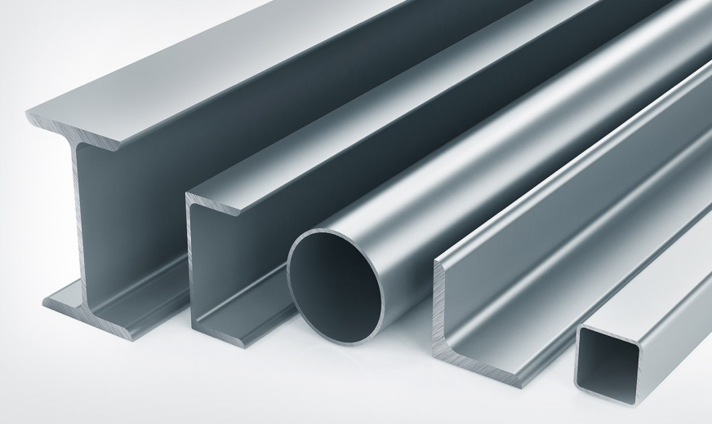
Innovation has been an essential aspect of all engineers, and in the early 21st century, new metallic materials and processes have been developed. Innovations in engineering and the metal industry are seeking to enhance the daily operations. It is apparent that metallic objects and processes are essential in the operations of machines and hence, innovation is inevitable. One of the current innovations in engineering which has fascinated many people is the crystalline aluminum. The crystalline aluminum was developed from a combination of the characteristics of aluminum which is a good conductor, has a low melting point, and creates strong alloys, rust-resistant an extremely light.
The crystalline aluminum was first created by a team of engineers and researchers from the Utah State University and the Southern Federal University in Russia in 2016(Whitwam 1). The creation of the crystalline aluminum was sought to convince engineers, scientists another exerts that it is possible to modify the qualities of different materials. It is apparent that aluminum is a very light metal, but it cannot float in water. However, innovation by scientists and engineers from the two universities has lead to the manipulation of the density of aluminum and the subsequent creation of the crystalline aluminum which floats in water despite the fact that it does not take the shape of a foil boat.
In the development of the crystalline metallic material, the engineers started by creating a crystalline lattice which was made up of diamond and afterward substituted it with an aluminum tetrahedron (Whitwam 2). The result was a crystalline aluminum which is referred by scientist as super tetrahedron aluminum. The crystalline aluminum has a density of 0.61 grams per cubic centimeter and this is compared to the density of a standard aluminum which is 2.7 grams per cubic centimeter. This can also be compared to the density of steel which has a density of 7.75 g/ccm. The low density of the crystalline aluminum makes it possible float in water (Chen 1421).Water has a density of 1g/ccm. The engineers and experts are deliberating on the possible uses of the crystalline aluminum, and there is a consensus that it will be used in wiring, spaceflights and the creation automotive parts of fuel-efficient machines. There is also an argument that this metallic object would be very instrumental in spaceflights and especially in rockets for reducing the weights of these machines and hence make launching easy and efficient.
In conclusion, it is apparent that this crystalline aluminum depicts a modern innovation in the development of metallic objects and also in the improvement of metallic processes. This metal is apparently a product of the innovative engineering processes. Despite the fact that the crystalline metal has not been included in the market, its applications are essential in engineering. The development of the crystalline aluminum has also lead to the creation of a new principle in metallic processes, and that is; using a known structure to create new materials. Through this approach, it will be possible to come up with new metallic materials.

Works Cited.
Chen, H., et al. "Mechanical properties of partially crystallized aluminum-based metallic glasses." Scripta metallurgical material 25.6 (1991): 1421-1424.
Ryan Whitwam"Scientists Design New Form of Aluminum That Floats"Extreme Tech (2017):1-4.

